STATE SPACE SEARCH - A state space is represented by a four-tuple [N,A,S,GD], where:

N - is the set of nodes or states of the graph. These correspond to the states in a problem-solving process.

A - is the set of arcs (or links) between nodes. These correspond to the steps in a problem-solving process.

S - a nonempty subset of N, contains the start state(s) of the problem.

GD - a nonempty subset of N, contains the goal state(s) of the problem. The states in GD are described using either:

1. A measurable property of the states encountered in the search.

2. A measurable property of the path developed in the search, for example, the sum of the transition costs for the arcs of the path.

A solution path is a path through this graph from a node in S to a node in GD.

**Logic as State Space Language**

* **Propositional and predicate logic** can represent:
  + Nodes: logical **assertions** or **truth values**
  + Arcs: logical **inference rules**
* **Search algorithms** can then traverse this graph to reach conclusions (e.g., derive a goal formula from axioms).

EXAMPLE 3.3.1: THE PROPOSITIONAL CALCULUS

The first example of how a set of logic relationships may be viewed as defining a graph is

from the propositional calculus. If p, q, r,... are propositions, assume the assertions:

q → p

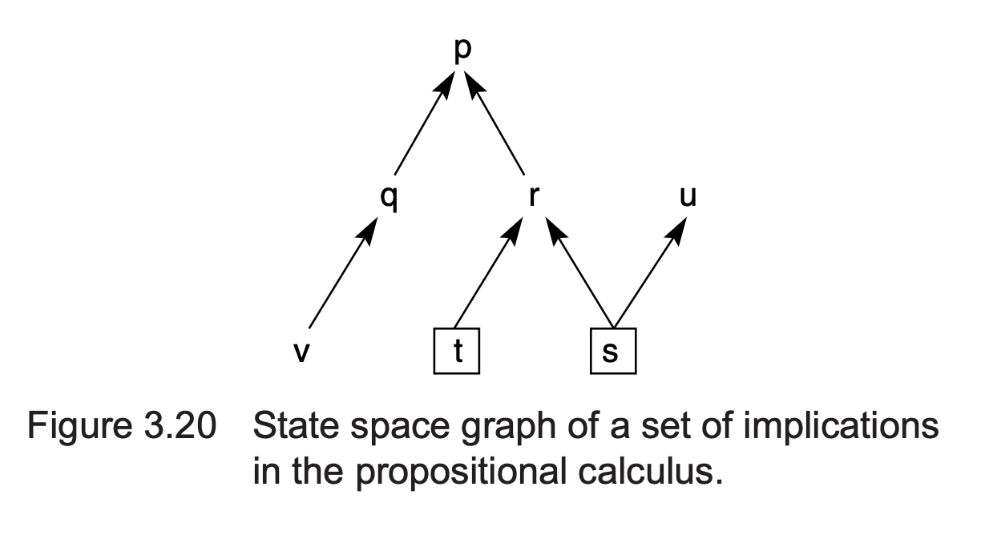

r → p

v → q

s → r

t → r

s → u

s

t

In Figure 3.20 the arcs correspond to logical implications (→). Propositions that are given as true (s and t) correspond to the given data of the problem

**FYI** - **Forward-Chaining** (start from known facts and infer new facts) and **Backward-Chaining** (start from goal and trace backward)

EXAMPLE 3.3.2: AND/OR GRAPH SEARCH

The second example is also from the propositional calculus but generates a graph that contains both and and or descendants. Assume a situation where the following propositions are true:

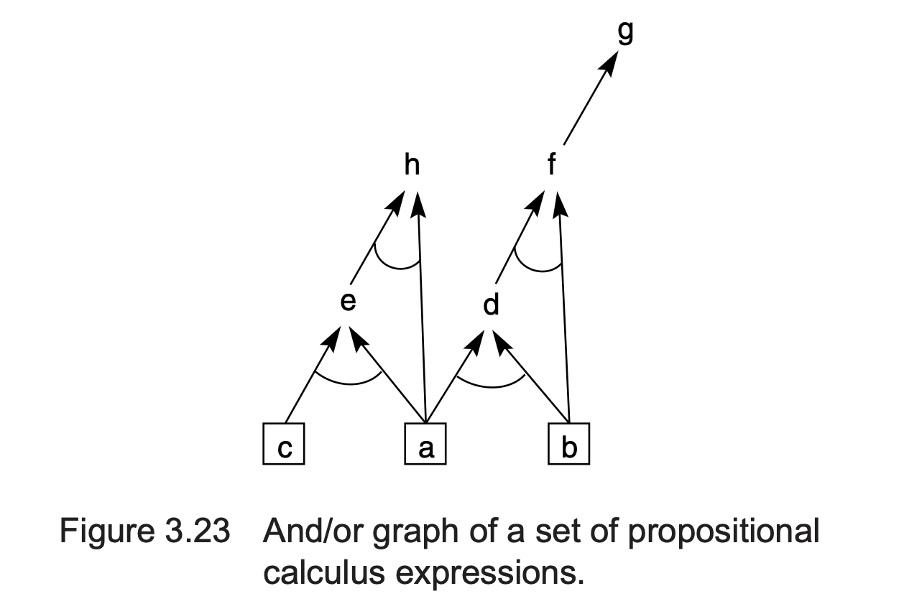

a

b

c

a ∧ b → d

a ∧ c → e

b ∧ d → f

f → g

a ∧ e → h

This set of assertions generates the and/or graph in Figure 3.23.

Questions that might be asked (answers deduced by the search of this graph) are:

1. Is h true? A and C are true -> E is true -> A and E are true therefore h is true.

2. Is h true if b is no longer true?

More examples:

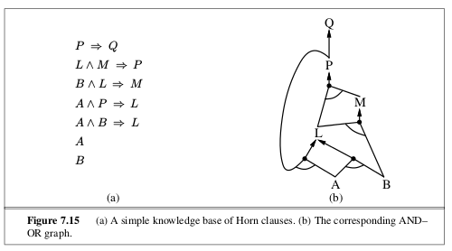

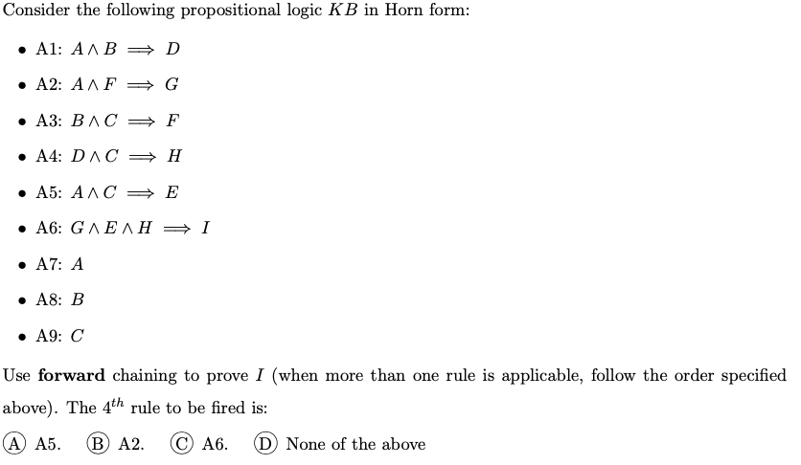

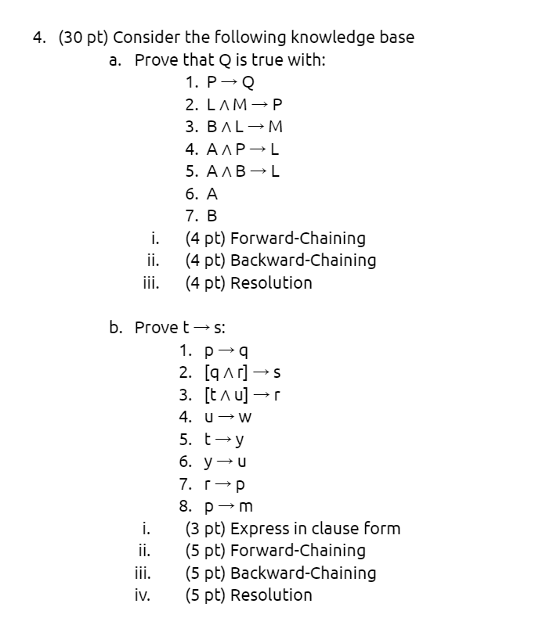

### ****Backward-Chaining**** (start from Q and trace backward)

**Goal:** Q

* To prove Q, need P (from 1: P → Q)
* To get P, need L ∧ M (from 2)
  + To get M, need B ∧ L (from 3)
  + We already have B
  + To get L:
    - (5): A ∧ B → L (we have both A and B) → infer **L**
  + Now have B and L → infer **M**
* Now L and M → infer **P**
* P → Q → infer **Q**

**Q is proven by backward chaining**

### ****i. Forward-Chaining**** (start from known facts and infer new facts)

**Known:**

* A
* B

**Step 1:**  
From (5): A ∧ B → L → infer **L**

**Step 2:**  
From (3): B ∧ L → M → infer **M**

**Step 3:**  
From (2): L ∧ M → P → infer **P**

**Step 4:**  
From (1): P → Q → infer **Q**

**Q is inferred by forward chaining**